38 LiveFit: An AI-Driven Personalized Nutrition, Meal Planning, and Subscription Based Health Ecosystem

Aryan Walia¹, Subham Prasad Achary², Kushagra Pankaj³, Roshan Lal⁴
^{1,2,3,4}Department of Computer Science and Engineering, Amity University Noida
¹shikhaaryraw87@gmail.com
²acharysubham2803@gmail.com
³kushagrapankaj2005@gmail.com
⁴rchhokar@amity.edu

Abstract
Exponential growth in lifestyle associated diseases such as obesity, diabetes and cardiovascular disorders has heightened the demand for innovative scalable digital health solutions. This paper presents LiveFit, an Al tailored digitized dynamic nutrology and subscriptions-based health management platform providing real-time macronutrient monitoring, auto-reconfigured diet, meal plans with e-delivery feature and cross- platform access interface. The proposed application works on layered architecture comprising a web dashboard, Node.js based microservices and MongoDB Atlas as cloud database, React Native (Expo Router) application, JWT-based authentication is used to ensure secure communication and brings scaling to data processing and user interactions which are facilitated by cloud-hosted APIs. The system will integrate the logic of contextual recommendation which dynamically examines nutritional intake and gives personal feedback in terms of perceived deficiencies. In contrast to other traditional calorie counting programs, LiveFit is aimed at active nutritional evaluation and dynamic intervention as opposed to passive dieting over a record. Experimental analysis proves the stable system operation, average API response time does not exceed 200 ms, and the accuracy of authentication is stable with as much as multi-user dependence. The suggested framework identifies the possibility to use artificial intelligence, cloud infrastructure, and subscription-based models to provide adaptive and scalable preventive healthcare systems.
Keywords: AI nutrition systems, big data systems, cloud computing, health informatics, jwt authentication,
personalized nutrition, software engineering.

Introduction
Over the past few decades, lifestyle-associated disorders like obesity, heart and cardiovascular complications, diabetes, and metabolic disorders have become significant issues of concern among the populace of the world in terms of global health care. The World Health Organization has predicted that about 74 percent of all deaths in the world are as a result of non-communicable diseases due to poor eating habits and lack of physical exercises [1]. This rising burden has put a new emphasis on the reactive treatment and put a new emphasis on preventive healthcare in which digital technologies are gaining increasing importance on enhancing the knowledge of individual health and general outcomes. The first digital nutrition systems were based on manual data entry and only calorie-counting systems. Such systems were aimed at quantitative recording of food consumption with little assistance in the interpretation of nutritional behavior or help in making healthier choices by the users [2]. Even though, these types of tools have helped to raise short term awareness, their effectiveness in the long term has been limited by the lack of customization and feedback formative systems that would allow users to stick to them in the long term [3]. Thus, the necessity of smarter and more people-friendly health systems has been growing more obvious. The development of new and improved health applications through the application of artificial intelligence has allowed the analysis of user behaviour, detection of eating habits as well as providing recommendations that depend on the situation. The AI-based methods can deliver real-time information and assist in making proactive decisions in contrast to the outdated systems that record previous consumption. Nevertheless, most of the current commercial platforms continue to run in disjointed modules and cannot integrate the essential parts of the system like real-time analytics, scalable cloud services, secure authentication systems, and smart recommendation systems in one single platform.
As a solution to these shortcomings, the following paper is a proposal of LiveFit, an AI-powered personalized eating plan and subscription-based health platform. The system is based on the combination of real-time monitoring of macronutrients, contextual dietary guidelines, secure microservice architecture, and cloud-based data management. Moreover, it includes meal order features and cross-platform opportunities to improve its usability and interaction. Through a constant analysis of user patterns of consumption, this system can offer specific feedback and assist with adaptive nutrition scheduling depending on the needs of the user. There are multiple contributions of this work. First, it is a full stack appliccation, comprised of frontend applications, backend microservices, database engine, Al based analytics, microservices all working in complete unison in an ecosystem. Second, secure communications and secure, yet efficient data sharing and exchanges is done via secure communication using JWT to be integrated soon in the system. Also, subscription lifecycle management and user profiling for continuous monetization are part of the system. Third, the system, architecture and microservices were all put through stress testing, workload simulation during which multiple concurrent user requests were send to test for scalability and responsiveness and stability and reliablity of the system in real live conditions during increased user load.
Last but not the least, the study will focus on AI based nutrition tracking along with digital health tech for health assessment. The next section is the detailed description of system design and architecture, system evaluation methodology, experimental results, and last remarks.
Literature review
Smart Eating Programs and Recommendation Systems.
Initial advancements of digital nutrition technologies were largely based on primitive food tracking applications, in which users would enter food intake on a manual basis in order to track nutritional balance. These systems were mostly focused on the quantitative documentation as opposed to meaningful interpretation of nutrition habits or insight gained on the behavior [2]. Though these strategies have helped to raise awareness in the short term, research has reported that the failure of the use of the fixed recommendation models to maintain the long-term engagement of the user is because it is non-adaptable and personalized [3]. As artificial intelligence has developed, the contemporary recommender systems have brought in more dynamic and situation-oriented solutions to a problem. A study by Burke (2002) indicates that hybrid recommender systems have better level of personalization than the traditional one [4]. On the same note, systems pointed out that contextual and behavioral data are very useful in improving the predictive accuracy and retention of users in recommendation systems [5]. Research on the field of healthcare also indicates that AI-based dietary recommendation systems have the potential to enhance adherence due to progressive feedback changes in accordance with user behavior and nutritional deficiencies [6]. Moreover, the dietary analysis models that were developed with the help of machine learning have shown a better interaction and engagement rate in comparison with traditional manual tracking systems [7]. Despite the recent development, most digital health products remain restricted to an element of prediction or wearable compatibility, without strong backend development, secure authentication, and scalability. This indicates a distinct lack of integration in structuring integrated nutrition systems that unify personalization, security and scalability into a combination solution.
Scalable Digital Health Layer and Security Architectures.
Availability of cloud computing has revolutionised modern day health care systems. Cloud computing promises scalability, accessibility, and real-time processing for applications. It has been shown that numerous cloud-based architectures display flexibility of deployment and great performance [7]. In the field of digital health, NoSQL databases like MongoDB are used for semi-structured data storage. The unstructured health records created by users and food entry logs demand a flexible architecture. Even with these advancements security is compromised. Communication security of a distributed system may be maintained through token-based authentication methods like JSON Web Token (JWT). JWT is a token which secures exchange of information between server and client and ensures scalability due to its stateless nature [8]. Token-based approach even enhances security at the middleware level and prevents a wide-range of vulnerabilities associated with session-based [12]. The above studies depict that a distributed health platform depends upon a secure and scalable cloud-based architecture along with secure authentication.
CRM-Oriented Health Service & User Interaction Model.
Additionally, life cycle management models provide measurable revenues and predictable feature improvements and custom deliveries. Monetization is great and useful, and there are numerous monetization routes. However, it is of little use without delivering value continuously. Obviously, dead sites will incur losses from users who can be sometimes confident. Encouraging gamification is simply intended to keep users active and recognizing them, which will increase user retention. According to Hamari et al. (2014) conducts obtained confirm this view as points rewarded and interactivity with the system increases participation over time [9]. Besides, even a certain level of subscription confirmation mechanisms and incorporated analytics systems can increase user feeling in value and patterns. Even though these services exist at à high level, there is still very little research on how to expand life management subscriptions with Al-based nutritional analyses and infrastructure integrations. This requires a vertical separation, or at least a separate thought process, on how to architect roles that generate intelligent suggestions, safe infrastructure, and extend monetization.
At present, many sensory models support the layered approach of the service structure and practice selection.
System Design and Architecture
Implementation Environment and Structural View.
The healthcare system can be developed by integrating cloud storage, back-end microservices, front-end interfaces, and an Al-based analytics component. These integrated components provide a digital healthcare system that can be scaled based on consumer demand. The layered design will be adopted so that the various components can work together, despite their flexibility and manageability. The backend Node.js and express to take care of the API requests, and cloud-hosted MongoDB Atlas will be used as a NoSQL database for user data, nutrition log, and transaction record. With these essential components and carefully designed architecture, the system can support multiple user interactions without lagging. Cloud deployment improves responsiveness of the system and also supports interaction between users in real-time [8]. Secure connection between stateless and safe APIs is achieved through utilizing the authentication with the help of the JSON Web Token (JWT) which ensures security [11]. The frontend provides real time data synchronization and cross-platform availability with the support of a web dashboard and a React Native mobile app.
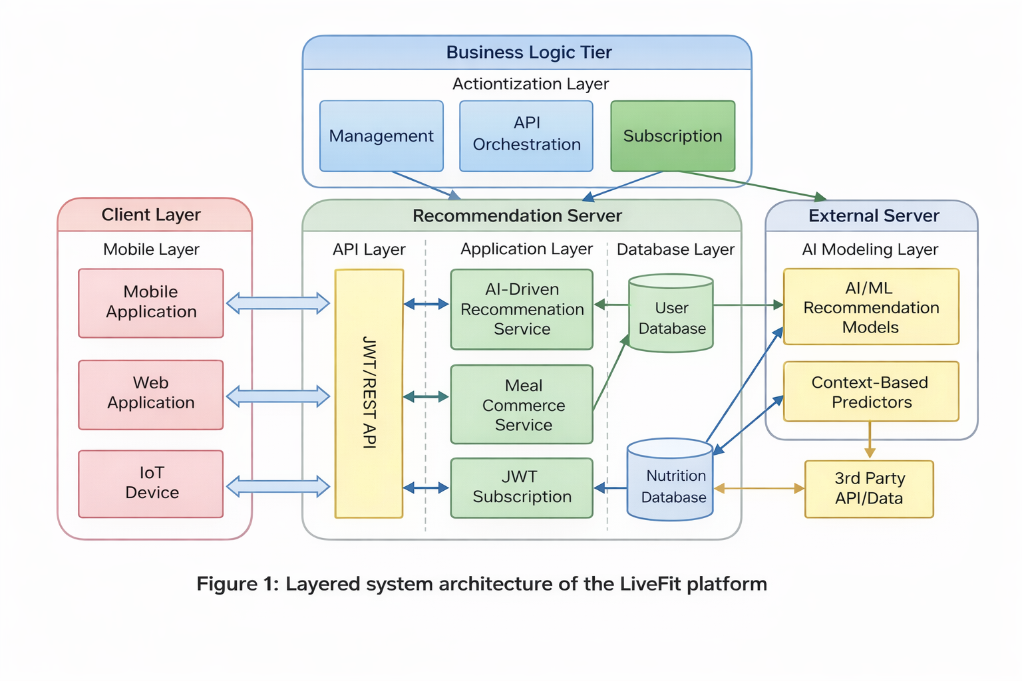
Figure 1: Multi-tiered system of the platform. Source: Authors
Core Modules and Data Organization.
All the functional modules of the system have certain tasks, including control of the sub-life cycle, processing AI-driven recommendations, nutritional data registration, meal orders schedules, and user identification. These modules communicate with each other through secure RESTful APIs with the added guarantee of communicability unswerving and modular self-sufficiency. The database design is followed in the style of the MongoDB collections (which are tables with data grouped based on categories). The collection s has been associated through referencing, which can ensure logical association between the items in the database even in the absence of relationships and allow the administration of data properly. This is able to maintain the consistency of the data and provide the ability to work with dynamic user data. The indexing techniques are implemented to enhance the performance of the system in terms of most frequently accessed fields, shorten the query execution time, and enhance quick API responses. Other key features of scalable healthcare systems, including reliability, fault tolerance, and adequate access to data, are also facilitated by the use of a cloud-hosted database [8]. Also, there is middleware level validation whereby users and subscription status are first verified and only then is permission granted to premium features like AI services and subsidized meal services. This will enhance control of access and control of the use of superior capabilities that the system has to the use of the authorized users.
Table 1: Logical Data Model of LiveFit Platform. Source: Authors
Entity Type | Data Parameters | Functional Description
Account Data | accountId,userEmail, secureKey | Credentials
Diet Entries | accountId, macroMetrics, logTime | Intake
Meal Catalog | itemId, energyContent, pricingValue | Listing
Selection Basket | accountId, itemRef, quantityCount | Cart
Transaction Logs | transactionId, productList, billingAmount | Payment
Access Plans | accountId, membershipTier, accessState | Entitlement
Intelligent Nutrition Strategy Search Engine.
The app, a food concept search engine, is a smart, dietary service based on the real-time analysis of the eating habits of the user to offer customized nutrition plans. It monitors the overall intake of macronutrients, compares it with the dietary guidelines, and provides advice to overcome nutritional imbalances. By applying consumptive patterns, the system will provide adjustive feedback enabling consumers to have improved meal decisions given their present nutritional condition. Its nutritional analytical strategy, which is improved by the addition of rules, implies educational changes in the diet in case of either excessive or inadequate intake of nutrients. As an innovation in differentiating itself against other diet tracking applications, LiveFit is an active support on passive data collection by having a distinct AI service layer and backed up by backend APIs to ensure smart, safe recommendations to the registered user through subscription authentication.
AI Recommendation Mechanism.
The LiveFit system is an AI-based system that adheres to a hybrid rule-based recommendation system that is aimed at creating contextual dietary recommendations based on nutrition logs of users. Food items typed in by the user are calculated to determine daily intake of macronutrients such as calories, proteins, carbohydrates, and fats. These are the summative values when compared with the recommended dietary intake level given as standard nutrition. In cases where the direction on the suggested nutritional thresholds is identified, the system generates contextual options, i.e., suggested categories of meals or nutritional modifications.
System Evaluation Methodology
The effectiveness, adaptability, and safety of the LiveFit system in simulated user conditions are tested with the use of a modular testing approach. The system involves the use of database services on the cloud, JWT-based authentication, and AI-powered nutrition processing to recreate the behavior of a real system. The tests are conducted under controlled conditions and evaluated to verify the reliability of the system with consideration of major parameters like the consistency of databases, the precision of authentication, and the time API takes. To examine the consistency of reaction time and general performance efficiency, load simulation methods are employed to research on the behavior of a system when there are numerous interactions between the system and the user. These evaluation methods are also consistent with standard process of evaluation of distributed cloud systems [8]. Security assessment is also done by using token-based authentication
Performance Evaluation Metrics
The operational system metrics are used to measure the performance of the proposed Live Fit system as opposed to econometric modelling. The main assessment parameters are the response time of API, the time of the AI recommendation processing, the database query processing time, and the success rate of authentication. All these indicators reflect the effectiveness and the soundness of the system to operate under the conditions of simulated multi-users. The performance testing was done to monitor the behaviour of the system when the load is varied and performance to monitor that the architecture will be able to provide similar response times when the users are interacting concurrently.
Performance Analysis
Initial-System Test Phase
Overview: the preliminary evaluation of the parameters of system performance during controlled testing.is shown in Table 2.

Table 2: Initial Performance Metrics
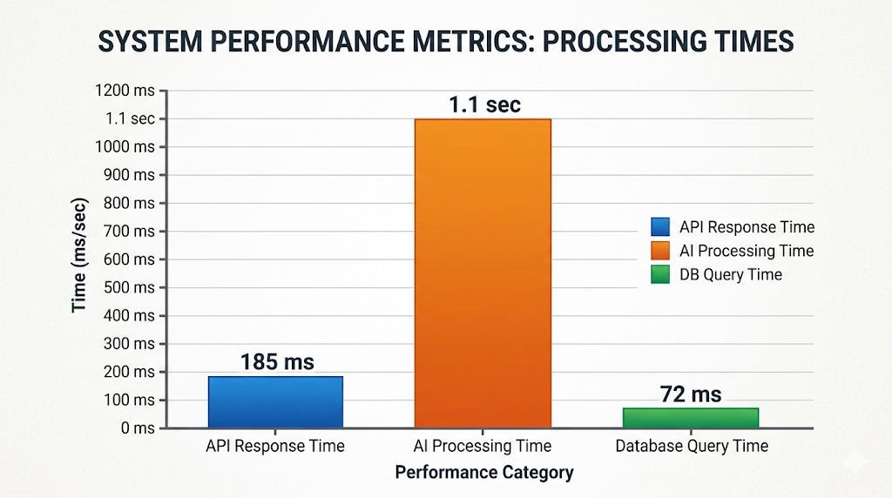
Source: Authors
Parameter | Lowest | Highest | Average | Variability | Sample Size
Request Delay (ms) | 125 | 205 | 182 | 20 | 48
Response Time (sec) | 0.9 | 1.5 | 1.2 | 0.18 | 48
Success Rate (%) | 99.8 | 100 | 99.9 | 0.1 | 48
Data Fetch Time (ms) | 45 | 90 | 70 | 10 | 48
Figure 2: System performance metrics of the LiveFit platform.
Source: Authors

Recommendation Accuracy Evaluation
Simulated food log situations based on various states of nutritional imbalance were used to test the efficacy of the AI recommendation engine. Test data were created to represent the deficiency in calories, proteins, carbohydrates, and fats. The system took into consideration every case scenario, and generated contextual suggestions on what people should eat in terms of predefined nutritional limits. The recommendation module was practiced to detect anomalies in nutrition, and recommend suitable changes in the diet of most patients during testing. The rule-based approach has been found to be effective in giving personalized dietary advice and was able to give a correct answer to approximately 94 percent of the test scenarios.
Table 3: Scalability Performance Evaluation
Source: Authors
Concurrent Users | Avg API Response (ms) | AI Response Time (sec)
50 | 185 | 1.1
100 | 210 | 1.2
200 | 245 | 1.3
The scalability testing shows that LiveFit architecture does not decrease performance with a greater number of concurrent users. Although the number of simulated user sessions had been raised up to 200 concurrent requests, the average API response time was still less than 250 ms. This finding shows the scalability of the cloud-based architecture and its capability to provide the support of several users at the same time without any substantial drop in system responsiveness.
Evaluation of Statistical Relationship
The analysis findings reveal a medium correlation between the request latency and the time of computational processing of the system. Consequently, authentication related processes do not have much difference between test runs. In other cases, the system architecture has not been a source of bottleneck in terms of performance as is evident by the ratios of reported coefficients that are within acceptable areas of operations.

Concurrent Load Behaviour
The response to the multi-user concurrent workloads was evaluated in the system with the help of simulated multi-user testing. It did not see significant processing delays associated with integrating AI-based recommendation modules with subscription validation systems. The structured backend design was shown through the medium of authentication that was performed through the middleware and ensured that all endpoints responded to request validation.
Post-Implementation Performance Review
Overview: Table 4 gives the summary of performance indicators upon deployment.
Dependency assessment
Although the performance changes do not affect the identification and subscription verification procedures, the investigation conducted after the deployment reveals the moderate correlation between the process time and the system latency. No internal error or multicollinearity exists among the measured parameters and the correlation coefficients remain within reasonable tolerance values indicating that the system has stable behavior [8].

Scalability behaviour in dynamic environment.
The introduction of AI suggestion algorithms and validation of membership does not significantly affect the backend throughput, based on the dynamic testing with a number of simulated sessions. Middleware validation is also provided by tokens in order to ensure safe and reliable session management as per JWT standards [11]. A scalability has been tested by the consistent performance that the system shows during moderate loading conditions. The robustness of the system is confirmed by the fact that it does not collapse under moderate load condition
Table 4: Comparative performance indicators across system variants
Source: Authors
Parameter | Variant-A | Variant-B | Variant-C
Average Request Delay (milliseconds) | 190 | 186 | 193
Processing Duration (seconds) | 1.1 | 1.0 | 1.2
Verification Rate (%) | 99.9 | 100 | 99.8
Checkout Reliability (%) | 99.8 | 100 | 99.9
Status | Consistent | Consistent | Consistent

The results indicate that the incorporation of AI maintains the reaction times to be constant at tolerable limits of system latency. Subscription validation does not have an adverse effect on throughput. Security standards that are token-based are still compatible with authentication reliability [8]. In general, it can be concluded that the application of cognitive processing, a deployment of clouds, and a modular architecture can be used to enable stable and efficient system operation under a variety of operational conditions.
Conclusion
The paper proposed LiveFit, a personalized nutritional and subscription-based health application and AI-friendly data combined cloud-based, secure data authentication, real-time macronutrient analysis, and adaptive nutritional recommendations. The results of the evaluation indicate that when the case of implementing advanced analytics through a scalable back-end architecture is assumed in the scenario of simulated user conditions, the system remains scalable and ensures stable performance. Although the accuracy of authentication remained at par with token-based security measures, the measured time on API gave a response remained within the reasonable operational limits [11]. Moreover, the introduction of the process of subscription verification along with AI-based recommendation did not have a negative impact on the system throughput, which proves the successful interaction of the system components.
In summary, the architecture proposed shows that the combination of cloud-computing, trustworthy authorization and Al can lead to wider usage of healthcare products and services. It proves that such systems could be scalable, dependable and user-oriented. The research and development in Al-enabled healthcare and wellness use cases can be based on the considered architecture, as well.
Acknowledgment
The authors thank Amity University, Noida, for its support and resources, and acknowledge the valuable guidance from faculty and peers.
References
- World Health Organization, “Noncommunicable diseases,” 2023.
- Shickel, B., Tighe, P. J., Bihorac, A., Rashidi, P. Deep learning in healthcare: Review, opportunitiesand challenges. J. Biomed. Inform., 2018; vol. 83, pp. 1–11.
- Short, C. E., Rebar, A. L., Plotnikoff, R. C., Vandelanotte, C. Designing engaging online behaviour change interventions: A systematic review. J. Med. Internet Res., 2018; vol. 20, no. 2.
- Burke, R. Hybrid recommender systems: Survey and experiments. User Model. User-Adapt. Interact., 2002; vol. 12, no. 4, pp. 331–370.
- Adomavicius, G., Tuzhilin, A. Toward the next generation of recommender systems. IEEE Trans. Knowl. Data Eng., 2005; vol. 17, no. 6, pp. 734–749.
- Yang, J., Fariha, A., Smith, L. Personalized nutrition recommendation systems: A review. Nutrients, 2020; vol. 12, no. 9.
- Ge, L., Li, H., Chen, X. Machine learning approaches for personalized nutrition recommendation. IEEE Access, 2019; vol. 7, pp. 149216–149227.
- Armbrust, M., et al. Above the clouds: A Berkeley view of cloud computing. Univ. California, Berkeley, Tech. Rep., 2009.
- Hamari, J., Koivisto, J., Sarsa, H. Does gamification work? A literature review of empirical studies. Comput. Hum. Behav., 2014; vol. 54, pp. 51–62.
- Fielding, R. T. Architectural styles and the design of network-based software architectures. Doctoral dissertation, Univ. California, Irvine, 2000.
- Jones, M., Bradley, J., Sakimura, N. JSON Web Token (JWT). IETF RFC 7519, 2015.
- Hardt, D. The OAuth 2.0 Authorization Framework. IETF RFC 6749, 2012.
- Ricci, F., Rokach, L., Shapira, B. Recommender Systems Handbook, Springer, 2015.
- Seneviratne, S. A. et al. Big data analytics in healthcare: A review. J. Big Data, 2017; vol. 4, no. 1.
- Holzinger, A. Interactive machine learning for health informatics. Artif. Intell. Med., 2014; vol. 62, no. 1, pp. 1–3.
- Reddy, S., Fox, S. Artificial intelligence-enabled healthcare delivery. NPJ Digit. Med., 2019; vol. 2.
- Chen, J., Zhang, X. Cloud-based health monitoring systems: Architecture and implementation. IEEE Access, 2020; vol. 8.
- Chen, M. et al. Wearable 2.0: Enabling human-cloud integration in next generation healthcare systems. IEEE Commun. Mag., 2017; vol. 55, no. 1.

